Project Planning Phase
Project Planning (Product Backlog, Sprint Planning, Stories, Story points)

Date | 20 February 2026
Team ID | LTVIP2026TMIDS24635
Project Name | Flight finder-navigating your air travel options
Maximum Marks | 5 Marks

Product Backlog, Sprint Schedule, and Estimation (4 Marks)

The product backlog represents a prioritized list of features and tasks required to complete the project.
These tasks are divided into sprints, and each task is assigned story points based on complexity and effort.

Sprint | Functional Requirement (Epic) | User Story Number | User Story / Task | Story Points | Priority | Team Members
Sprint-1 | Data Collection | USN-1 | Collect data from various APIs/sources | 2 | High | 1
Sprint-1 | Data Collection | USN-2 | Load collected data into storage/memory | 1 | High | 2
Sprint-1 | Data Preprocessing | USN-3 | Handle missing values in dataset | 2 | Low | 3
Sprint-1 | Data Preprocessing | USN-4 | Convert/encode categorical data | 2 | Medium | 4
Sprint-2 | Model Building | USN-5 | Build a machine learning model to recommend  or classify flights | 5 | High | 1
Sprint-2 | Model Building | USN-6 | Test model accuracy and performance | 3 | High | 2
Sprint-2 | Deployment | USN-7 | Design working HTML pages for frontend | 3 | Medium | 3
Sprint-2 | Deployment | USN-8 | Deploy using Flask and integrate model | 5 | High | 4

Project Tracker, Velocity & Burndown Chart: (4 Marks)

Sprint | Total Story Points | Duration | Sprint Start Date | Sprint End Date (Planned) | Story Points Completed (as on Planned End Date) | Sprint Release Date (Actual)
Sprint-1 | 8 | 5 Days | 4 February 2026 | 10 February 2026 | 8 | 10 February 2026
Sprint-2 | 16 | 5 Days | 11 February 2026 | 18 February 2026 | 16 | 18 February 2026

Velocity:
Imagine we have a 10-day sprint duration, and the velocity of the team is 20 (points per sprint). Let’s calculate the team’s average velocity (AV) per
iteration unit (story points per day)
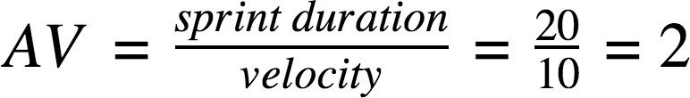

Burndown Chart:
A burn down chart is a graphical representation of work left to do versus time. It is often used in agile software development methodologies such as Scrum. However, burn down charts can be applied to any project containing measurable progress over time.

